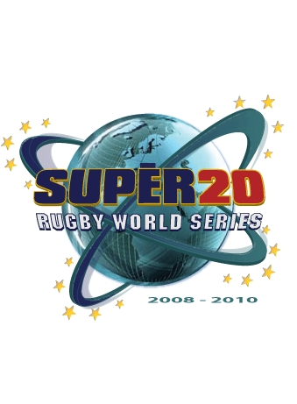
October 2007
No. | Name | Country | City - State | Mayor
1 | Philadelphia | USA | Philadelphia - PA | John F Street
2 | St. Louis | USA | St. Louis - MI | Francis G Slay
3 | Boston - | USA | Boston - MA | Thomas M Menino
4 | New York | USA | New York - NY | Michael R Bloomberg
5 | Charlotte | USA | Charlotte - NC | Patrick McCrory
6 | San Francisco | USA | San Francisco - CA | Gavin Newsom
7 | Denver | USA | Denver - CO | John W Hickenlooper
8 | Chicago | USA | Chicago - IL | Richard M Daley
9 | Sao Paulo | Brazil | Sao Paulo | Gilberto Kassab
10 | Mexico | Mexico | Mexico City | Marcelo Ebrard
11 | Vancouver | Canada | Vancouver | Sam Sullivan
12 | Toronto | Canada | Toronto | David Miller
13 | Perth | Australia | Perth | Lisa Scaffidi
14 | Windhoek | Namibia | Windhoek | Matheus K. Shikongo
15 | Nelson Mandela Bay Spears | South Africa | Nelson Mandela Bay | Nondumiso Maphazi
16 | Soweto Warriors | South Africa | Soweto | Amos Masondo
17 | Krasny Yar | Russia | Krasny Yar | Pyotr Pimashkov
18 | Hannover | Germany | Hannover | Dr. Herbert Schmalstieg
19 | London | England | London | Ken Livingstone
20 | Belfast | Ireland | Belfast | Jim Rodgers
Challengers-In-Waiting Series
1 | Dallas | USA | Dallas - TX | Thomas C Leppert
2 | Kansas | USA | Kansas City - KS | Joe Reardon
3 | Edinburgh | Scotland | Edinburgh | Jenny Dawe
Super 20 Rugby World Series Host State
 | Wilmington | USA | Wilmington - DE | James M Baker
Focus
To promote and foster strong and prosperous relationships between the Super 20 Rugby World Series Franchise Teams parent cities, through the annual rugby tournament and especially to grow economic, business, cultural, tourism and trade links to an international television and media audience of millions.

Www.super20rugby.com info@super20rugby.com

